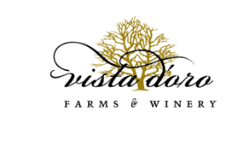
Vista D’oro Farms

About:

Vista D’oro Farms is a culinary agritourism destination located in South Langley, BC on ten acres overlooking Campbell Valley Park and Golden Ears Mountain Range, just 45 minutes South of Vancouver.
Dedicated to providing an ultimate agritourism experience, Vista D’oro Farms & Winery grows heritage orchard fruits, heirloom tomatoes and grapes all of which can be found in the Farmgate Shop & Tasting Room in some form – whether in our flagship D’oro - fortified walnut Wine, our Orchard Pear & Pinot Noir preserves or our Hand-cut Heirloom Tomato Salsa.
Our Farmgate Shop and Tasting Room is open Thursday through Sunday from 11am until 5pm. We look forward to welcoming you to our farm and sharing our passion for great food and fine wines.
Patrick & Lee

About Wines
Vista D’oro Winery is dedicated to producing delicious hand-crafted wines. The traditional techniques and old world values that are used in our artisanal preserves are reflected in our winemaking methods. Made in small batches on our farm to be shared with family and friends, new and old. We hope you enjoy!
Patrick & Lee

Wine types:

Wines
- 2008 D'oro

The ONE that started it all! The flagship of Vista D'oro, this fortified walnut wine is a blend of Marechal Foch, Merlot & Vista D'oro Green Walnuts and BC Brandy. 8 years in French and American oak. This artisanal fortified port-style wine is made from BC’s finest vinifera and hand made in small batches. A truly unique offering.

Click the links below for more wines info.

- 2013 Murphy's Law Red
http://www.vistadoro.com/wines/2013-murphys-law-red

- 2012 - Farmstead Cider
http://www.vistadoro.com/wines/2012-farmstead-apple-cider

Chaberton Estate winery

About:
Located on 55 acres, amongst the rolling hills of south Langley, British Columbia and just 45 minutes from Vancouver, Chaberton is one of the largest estate wineries in British Columbia and the oldest in the Fraser Valley. Our wines have won numerous awards in wine competitions held throughout Canada, the United States and Europe.

Our history dates back to 1975 with Claude and Inge Violet, our founders, who, having sold their winery and vineyard in France, decided to start afresh in the 'New World'. After visiting California, Ontario and the Okanagan Valley of British Columbia, Claude and Inge felt that to better service customers, it was important to be located in what is now Metro Vancouver. After extensive research, the Violets found that the terroir in south Langley was similar to that of some of the best wineries in northern France and would be ideal to grow cool weather grape varietals. In the beginning the Violets experimented with numerous grape varietals to see which ones were best suited. In the mid 80's, they began planting in earnest. In 1991, their first year as a Farm Gate winery, they produced 3,000 cases. Today, the winery produces in excess of 50,000 cases of wine a year made not only from grapes grown in our vineyard but also from grapes grown in the Okanagan and Similkameen Valleys.

Wine Types: Click the links below to visit

White & Rosé Wines
http://www.chabertonwinery.com/white_rose_wines.php

Red & Dessert Wines
http://www.chabertonwinery.com/red_dessert_wines.php

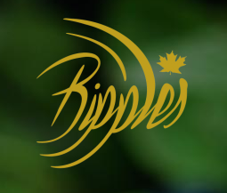
Ripples Winery

About:
At Ripples Winery, we believe in creating pure unique products by using our own blueberries and produce grown on our farm. Great wines start with great soil and the Fraser Valley is known for its Blueberry production. Within our Valley there are little pockets of micro-climate like ours, that can produce the best of the best. All our wines are hand crafted and bottled onsite ensuring our products are local and wholesome. The winery is a family operated business and with help and support from friends we have made many styles of wines to appeal to every palate and pair with many meals. We invite you to come see what our winery has to offer!
List of Wines they Offer
Lady 2013
Sourced from the Okanagan, this wine comes from the finest Cabernet Franc, Merlot and cabernet Sauvignon grapes and is aged 42 months in 100% French Oak barrels.With a certain complexity this blend has stunning aromatic notes and would be a perfect addition to any feast.
In·tem·per·ance 2015
This wine is made with a combination of modern and classical red wine making techniques, with the intention of preserving varietal flavour integrity and enhancing mouth feel complexity. With its high quantity of antioxidant and rich content of tannins, it seems that blueberry wine is one of life's healthy indulgences. Deep dark colour, intense blueberry aroma and equally flavourful taste.
Baby Munday 2015 and for more go on this link
http://rippleswinery.com/wines/

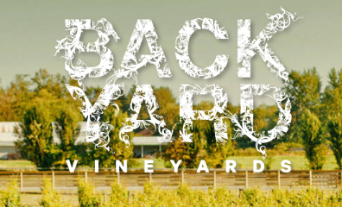
Backyardvineyards

About:
Wine lovers: for exceptional BC VQA wines in an exceptional local setting, look no further than Backyard Vineyards in the Township of Langley—the spacious, bountiful backyard to Vancouver, British Columbia. Since 2009, we have been producing award-winning varietals, blended, and bubbly wines from 100% BC grapes grown on-site in our own vineyard and complemented with fruit selected from the Fraser Valley and South Okanagan. Enjoy sipping in your own backyard, or let our vineyard be the perfect backdrop for a private tasting or event in our tasting room and under the gazebo.
Wines they offer:

2015 Reserve Syrah
An extremely complex but well-integrated nose of blackberries, blueberries, black pepper, smoked meat, dried provencal herbs and bacon flat.
A perfect blend of sweet and savoury flavours persist in this big-bodied wine. Black berries, blue berries and ripe plum harmonize with fresh cracked pepper, black olive and violets, while the fine-grained elegant tannins drag on the long lasting finish. Unfiltered so expect some sediment.

2014 Reserve Cabernet Sauvignon
Plum, Black Cherry, Cigar Box, Mint, Dark Chocolate and Tar on the nose. A perfect blend of Ripe Strawberry, Red Liquorice, Violets and Oak Spice.
Backyard Vineyards 2014 Cabernet Sauvignon Reserve was grown in Osoyoos, off HWY #3. Low yields well-drained loamy soils of basil leaves. This wine is structured, rich and intensely complex. We’ve chosen predominantly neutral oak with 10% new. A mixture of French and American oak allowed the wine to develop in its natural course. Enjoy with a well marbled Ribeye or Mushroom Beef Stroganoff.

Click here for more info regarding wines
http://www.backyardvineyards.ca/wine/

Blackwood Lane Winery
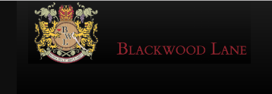
About:
Blackwood Lane Winery was the dream of Carlos Lee and that of his oenophile partners. Their goal was simple, to produce wines that lived up to their high standards and expectations. Their philosophy is summarized in the Company’s motto: “Bonus Vita et Bonus Amici” (Good Life and Good Friends).
Our wine tastings are fun, relaxed, and welcoming! We’d love to introduce you to our award-winning wines, and show you around our winery as well! Their wine tastings are great for the oenophile or those who are new to wine! Tasting Room is open Wednesday through Sunday, from 11 to 5. For groups of 6 or more, please make a reservation.
- White Wine Tasting
- Value Tasting (Red & White)
- Connoisseurs Tasting (Red)
Wine types:

2013 Cabernet Franc
A bright and cheerful wine! Elegant earthy aromas and flavours of sweet plums, black currants, raspberries, gooseberries, spicy peppers, violets and nutmeg. Finishes long with bright, slightly piquant fruit. A very versatile red that can pair lovely with cedar plank salmon, or earthy dishes with olives and feta. Try it with stuffed Portobello mushrooms, grilled red peppers, or turkey with cranberry sauce. The possibilities are endless with this delicious wine!

Explore the wines from here
https://www.blackwoodlane.ca/wines.html

